**Load Balancer**

Creation of Virtual Network

Creation of first Virtual machine under the network

Creation of second Virtual machine under the network

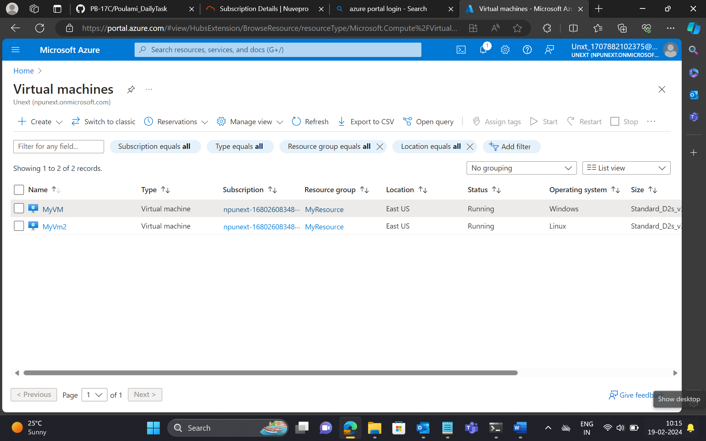

Load Balancer

Creation of new resource group

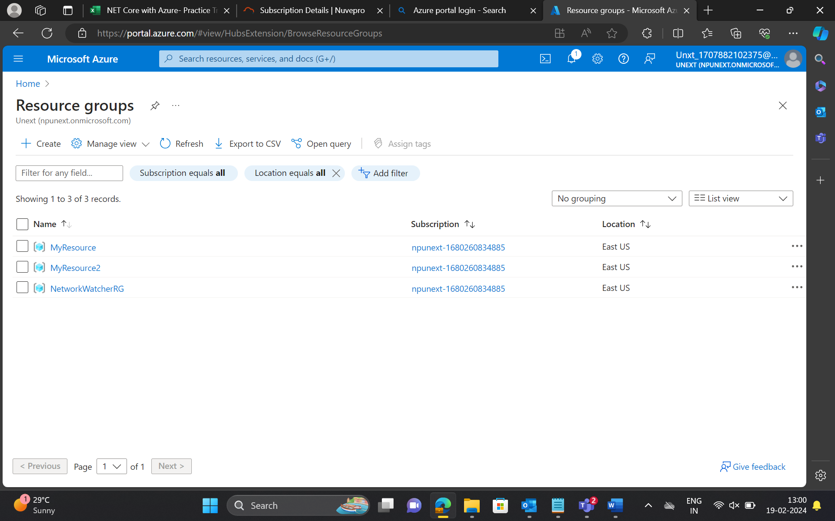

Create a virtual Network

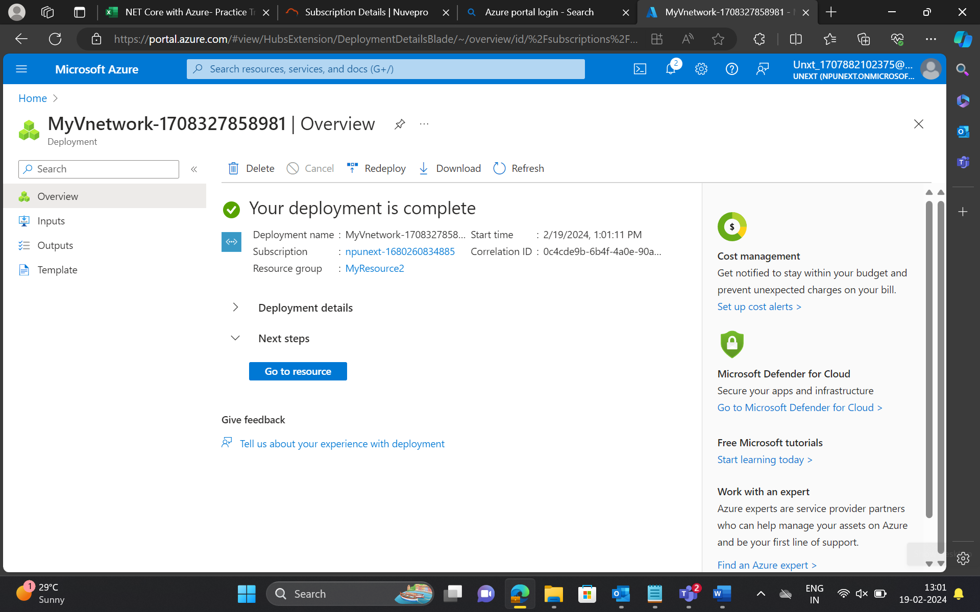

Creation of load balancer under MyReSource2

To connect the webserver

Creating another Virtual machine using same load balancer under MyResource2

Creating a web server for Virtual machine 1 (vm1)

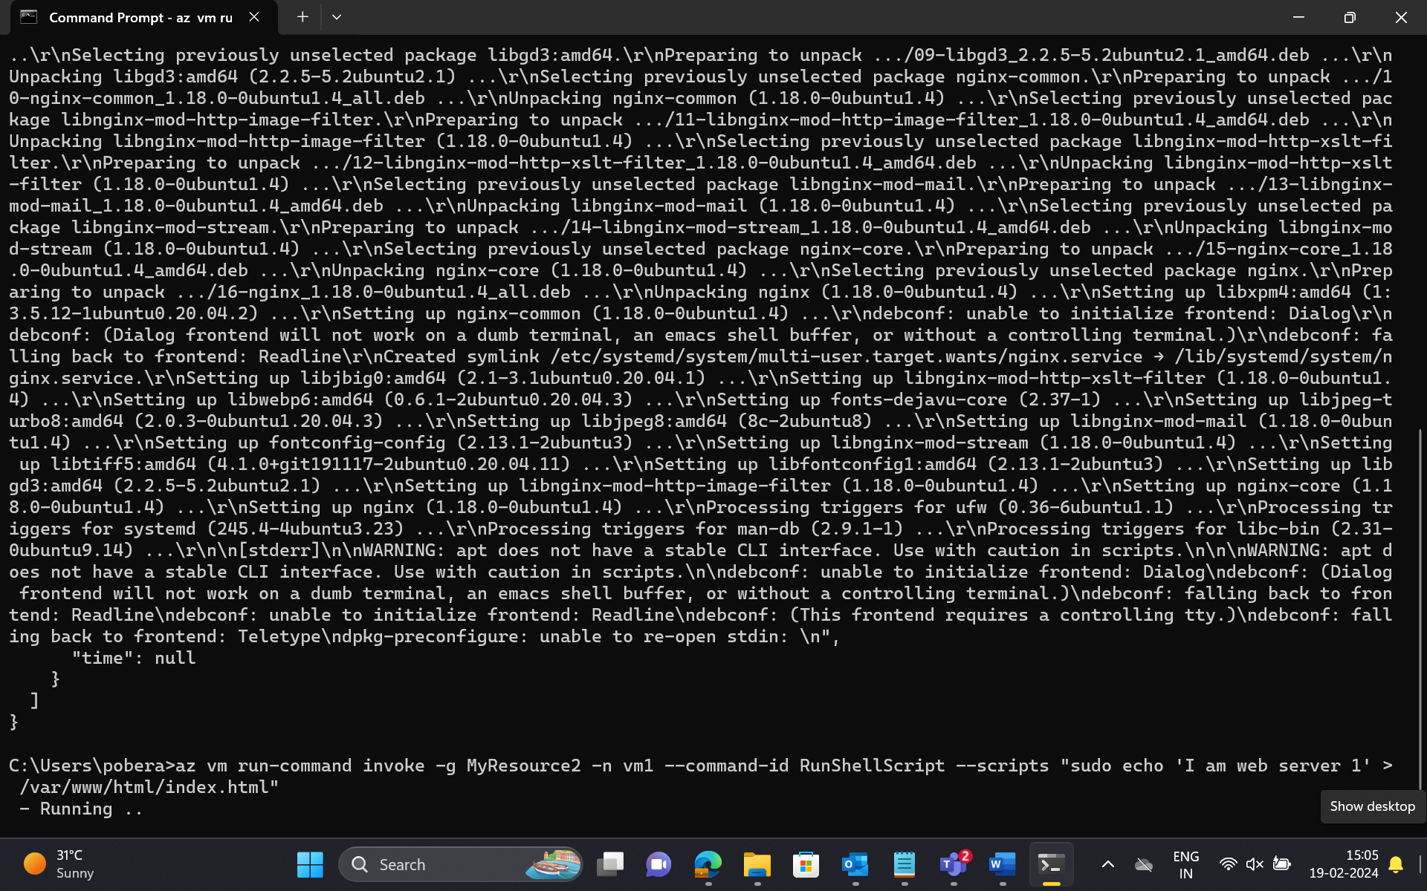

Creating another server for Virtual machine 2(vm2)

Creating index.html file for vm1

Creation of index.html file for vm2

Copy the IP address of vm1

Paste It chrome tab

Copy the IP address of vm2

Paste it in chrome tab

Stop server of Vm2

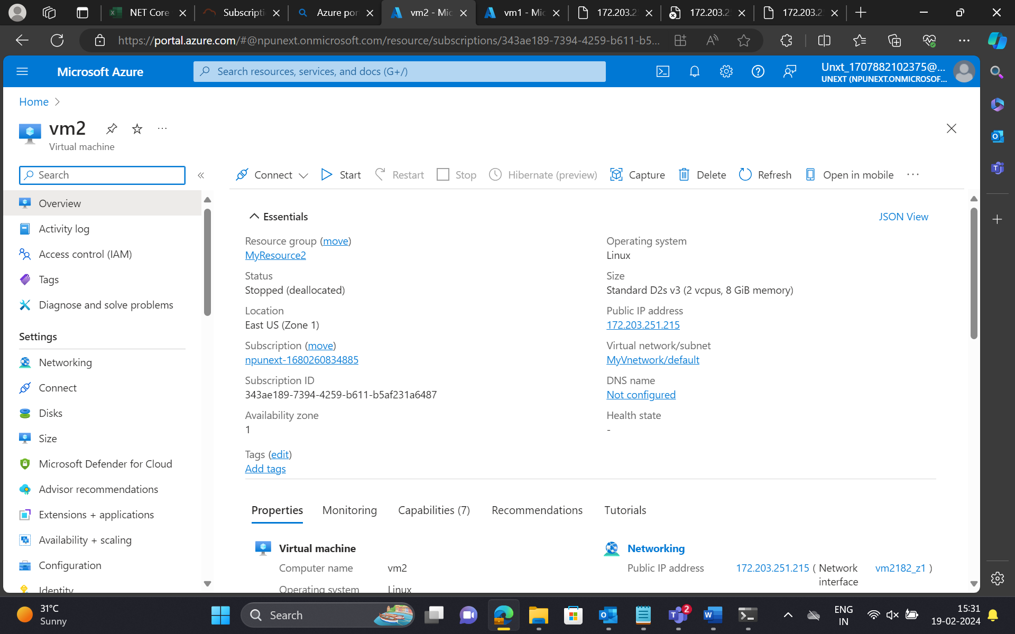

Then copy the IP address of load balancer.

Now it will be shifted to the server of vm1 that is server 1

**Global Load Balancer**

Creation of a new server (virtual machine) with new load balancer

Creation index.html for server (virtual machine3) vm3

